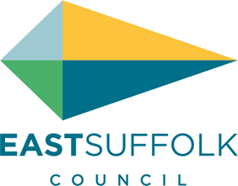

**May 2025**

Welcome to my monthly newsletter

**VE 80 EVENTS**

I was delighted to be involved with events in Hollesley in celebrating this important national day . We all know we live in a special place in the uk , so was really pleased to see the flypass just about go over the field at the bottom of my garden - so a great start to the week .

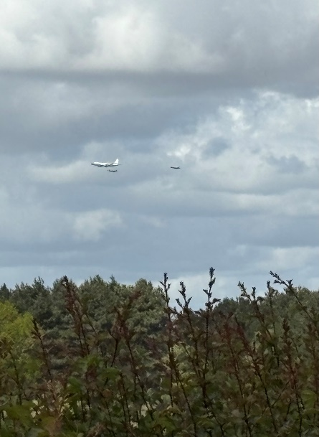

Then on VE day itself , I joined my fellow bell ringers and we rang at 630 . This was a national ring , and there is something very moving to think all the church towers were ringing at the same time across the Uk . Margaret one of our ringers gave us a special keyring to mark the occasion.

Then finally I was able to attend the Hollesley VE celebration on Saturday night .

Through my enabling community grant I was able to support the event , so ticket prices were discounted and the village hall was decorated making it look very atmospheric .

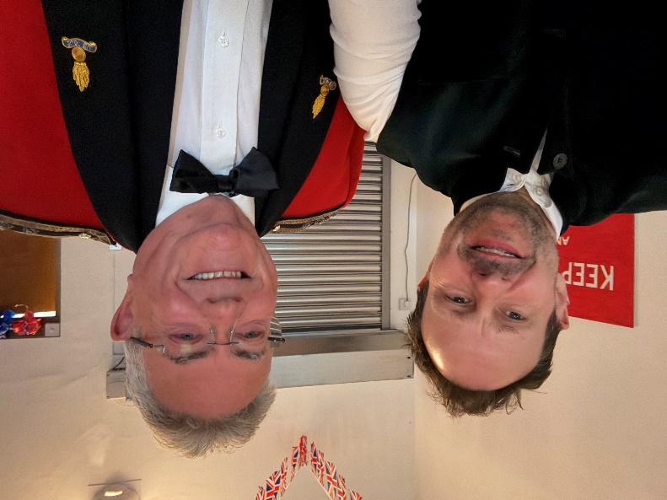

Over in Shottisham I also supported their VE80 celebration through my enabling communities grant supporting refreshments for the village when they lit their beacon.

**SUPPORT FOR BROMESWELL AND A REQUEST TO SUSPEND FURTHER PLANNING APPLICATIONS ON THE PENINSULA**

Bromeswell Parish council had their annual village engagement event and I was again able to attend and take the opportunity to talk to residents and pick up on any issues .

These outreach activities are really important as a councillor – to be accessible and to talk to residents to understand concerns and problems .

Much of local concern , as with many parishes on the peninsula, is the increasing traffic problems esp by Wilford Bridge roundabout and the roads leading to this junction .

I see no initiatives from East Suffolk or the County council to alleviate the problems and as more houses ( 65 house at Eyke 120 cars possibly ) are being built the situation will only get worse , I believe we are fully at capacity .

I therefore issued a press statement commending the parish council for their local engagement , celebrating all things Bromeswell and the most important , a calling on East Suffolk to reject any new house building applications until the road / traffic issue has been resolved .

I will in the coming months be writing to head of planning and the head of the planning committing again expressing our concern of the lack of interest in resolving this issue .

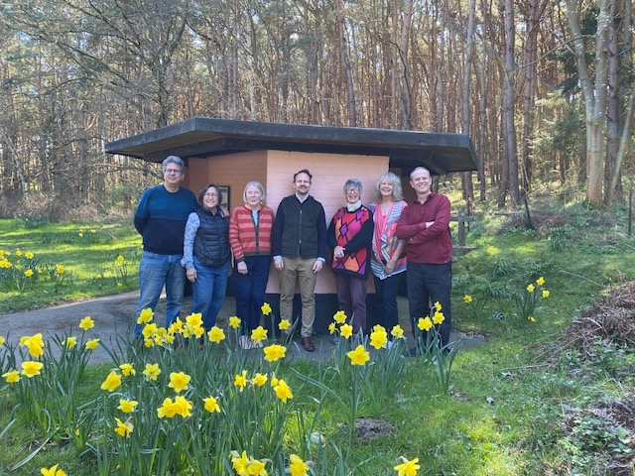

ARTICLE IN SUFFOLK NEWS CAN BE READ :

https://www.suffolknews.co.uk/woodbridge/no-more-homes-until-highways-issues-are-fixed-villagers-t-9413506/

**BAWDSEY QUAY**

Increased parking , congestion and aggressive visitors has resulted in the police being called to Bawsdey Quay to deal with a number issues . I have now picked up the issue and I am working with residents , Bawdsey PC , police and car park wardens from East Suffolk .

I have arranged for additional police patrols - esp at weekends and the car park wardens are making sure they check on the area in a timely manner .

**Footpath issues**

There seems little interest in sending in a routine road sweeper across my patch to keep the pavements clean so I am trying to flag soon as I am alerted to issues.

Photos of Eyke main road and the road between Bawdsey and Alderton

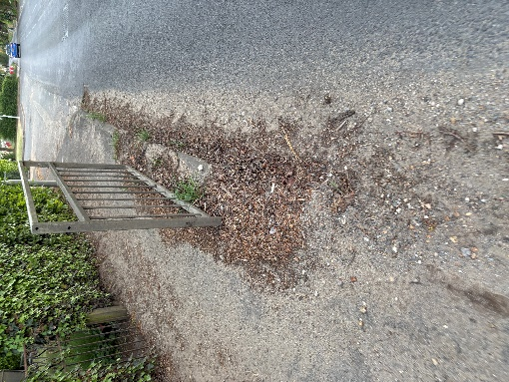

I therefore continue to work with the respective parish councils to see where the responsibility rests – normally East Suffolk or Suffolk county council .

I then report and then chase , to make sure prompt cleaning takes place.

The system really needs to be better and would like to see a regular twice a year clean without residents , PC and myself having to nag to have properly cleaning .

Public pride should be strong in all councils .

**Stop press**

* Lots of ploughing this time of year I encourage all parishes to make sure footpaths are walked – esp across fields and all access issues are quickly logged with Suffolk county council so these footpaths remain accessible for all

* I spoke to Jackie Abbott our community police officer - she is more than happy to come to a parish meeting and hear concerns and more importantly can arrange for an official police speed watch to take place – something I am encouraging all parishes to arrange
* And the peninsula continues to be one of few areas attracting many endangered species - I have spotted swallows, heard a cuckoo and seen variety of butterflies in the garden ,how lucky we are.

**James Mallinder**

**Deben Ward**

**A voice for parishes and residents of the Peninsula**