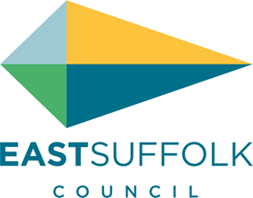

**November 2024**

Welcome to my monthly newsletter

**End of year update**

On the whole there has been very little new initiatives at East Suffolk but I am pleased to see policies and projects continue from the last 4 years .

As you know I continue to be disappointed in the lack of environmental engagement and I am disappointed to see my Pardon the weeds campaign and the annual district wide litter pick cancelled

I will be working hard to push the council to reintroduce both initiatives in the new year .

I continue with case work from local residents often guiding to which institutions to contact and assisting where I can .

And of course I speak out in meetings and at full council to articulate our views . And I continue to try and influence decisions so they best support our concerns .

I continue to engage with other local stakeholders and I work with Cllr Reid and Suffolk County Council where appropriate esp in highways matters .

With the change in our local member of parliament after a number of emails I am delighted finally a meeting will be scheduled and I will discuss the issues that clearly have an impact on the Peninsula

* Rual isolation
* Removal of the winter allowance
* Investment in our highways
* Water quality of the Deben
* And the bigger issues of how wealth distribution , housing issues and education

**Proposed changes in waste collection**

At Full council in  Sept   the Conservative group  have been quick to highlight  the faults in a hastily designed  new collection format to meet national requirements for 2026 . Much work had commenced in looking at how  East Suffolk would change it’s waste collections and before the Green and Lib Dems took over the council , pilot schemes were in the pipeline and the whole council , cross party , were focusing on the best outcome for our residents. However since the Greens and Lib Dems have taken power,  there is little cross party working and the  administration  is rubber stamping decisions that are clear to everyone have been made behind closed doors .

Nobody would argue that recycling  is more important  then ever with increasing climate change and improvements can be made in East Suffolk , but the current administration seems to forget  the  most important aspect of these changes are how easy they are for the busy household to following  . Not only the proposals of even more bins  , which will create confusion , but   there  will  be greater  congestion on pavements .

More bins will mean more plastic bins  which are not only unsightly  in many of our Victorian roads,  are simply the wrong type of  collection vessel  . We all understand the need to move away from plastic not use it more in our everyday lives .  The proposed sorting at home is just not practical  , where will all these bins be stored  ?    And the proposals as they stand  will be highly confusing to many of our residents esp the elderly and those with mobility issues  .The  key aspect  in recycling is to reduce the contamination to a minimum . If  bins are contaminated it becomes residue waste  and  is just burnt or worse still goes to land fill and that’s  just throwing away the hard work of  household sorting and collecting material in the first place . Recycling to be effective  needs to be simple.

I will continue to push theses issues and try to steer the council to make the right decisions .

**Environment grants**

When I was in charge of the environment portfolio at East Suffolk I was really pleased to introduce a new local biodiversity grant   
This has been resurrected and am really pleased to see this return

East Suffolk has a very important part to play to encourage communities to engage with our local biodiversity

And as you come to landscape around the village this grant is important to help support you with your projects

**https://www.eastsuffolk.gov.uk/environment/east-suffolk-greenprint-forum/supporting-community-environmental-action/nature-first-small-grants-scheme/**

**Remembrance Sunday**

After ringing Sunday bells I attended the Hollesley remembrance service . Beautiful morning sun shining for the first time for a long time

**Hollesley crash causing weeks of delay**

A collision between a van and tractor resulted in the tractor being overturned . This in turn resulted in damage to the tarmac and the road was closed for over three weeks.

This caused quite a problem in Hollesley with no access to this junction effectively closing the main road in the village . Works were taking too long so I spoke out to Suffolk County Council , working with Cllr Reid to minimize delays to the repair and to make sure standard of works were acceptable . Road markings have now been painted and I am working with Hollesley Parish council to investigate if road signage is adequate.

<https://www.eadt.co.uk/news/24633997.hollesley-road-repaired-three-weeks-tractor-crash/>

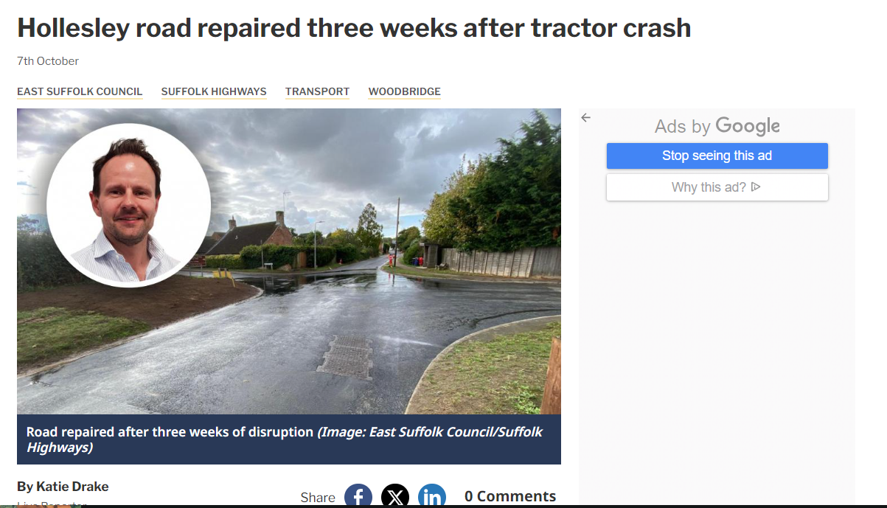

**Finally**

I wish you all a great christmas and peaceful new year . Look forward to working with you in 2025

**James Mallinder**

**Deben Ward**

**A voice for parishes and residents of the Peninsula**